NAMA : MAULANA MUHAMMAD  
NIM : 1918008

KELAS : A

**COMPUTER VISION**

**EKSTRAKSI FITUR PADA CITRA KERAMIK**

|  |  |  |  |  |  |  |  |  |
| --- | --- | --- | --- | --- | --- | --- | --- | --- |
| **No** | **Citra** | **Pixel Distance** | **Constrast**  **(Avg)** | **Correlation**  **(Avg)** | **Energy**  **(Avg)** | **Homogeneity**  **(Avg)** | **(avg(homogeneity + avg(energy))/2** | **Klasifikasi citra** |
| 1 |  | 1 | 0.50353 | 0.80711 | 0.17224 | 0.8493 | 0.510771 | Permukaan Kasar |
| 2 |  | 1 | 1.0293 | 0.80291 | 0.12476 | 0.79176 | 0.458261 | Permukaan Kasar |
| 3 |  | 1 | 0.59288 | 0.57349 | 0.13792 | 0.7583 | 0.448111 | Permukaan Kasar |
| 4 |  | 1 | 0.044686 | 0.54043 | 0.86145 | 0.97767 | 0.91956 | Permukaan Kasar |
| 5 |  | 1 | 0.39342 | 0.11705 | 0.45292 | 0.83914 | 0.646029 | Permukaan Halus |
| 6 |  | 1 | 0.27482 | 0.75853 | 0.26484 | 0.91207 | 0.588454 | Permukaan Kasar |
| 7 |  | 1 | 2.0791 | 0.70912 | 0.066933 | 0.68306 | 0.374998 | Permukaan Kasar |
| 8 |  | 1 | 0.18211 | 0.66595 | 0.42032 | 0.91183 | 0.666073 | Permukaan Halus |
| 9 |  | 1 | 0.25096 | 0.50411 | 0.32137 | 0.87468 | 0.598027 | Permukaan Halus |
| 10 |  | 1 | 1.0804 | 0.43963 | 0.098092 | 0.69697 | 0.397531 | Permukaan Kasar |
| 11 |  | 1 | 0.55851 | 0.88826 | 0.083811 | 0.81274 | 0.448277 | Permukaan Kasar |
| 12 |  | 1 | 0.16066 | 0.47063 | 0.60062 | 0.92035 | 0.760484 | Permukaan Halus |
| 13 |  | 1 | 0.29612 | 0.91421 | 0.14305 | 0.87162 | 0.507333 | Permukaan Kasar |
| 14 |  | 1 | 1.666 | 0.39414 | 0.10235 | 0.65014 | 0.376244 | Permukaan Kasar |
| 15 |  | 1 | 0.69049 | 0.84706 | 0.078539 | 0.76324 | 0.420889 | Permukaan Kasar |
| 16 |  | 1 | 0.16827 | 0.72161 | 0.4138 | 0.93564 | 0.674719 | Permukaan Halus |
| 17 |  | 1 | 0.62942 | 0.60732 | 0.15428 | 0.77853 | 0.466405 | Permukaan Kasar |
| 18 |  | 1 | 0.28534 | 0.86264 | 0.16838 | 0.8678 | 0.518088 | Permukaan  Kasar |
| 19 |  | 1 | 0.61373 | 0.68284 | 0.12316 | 0.77101 | 0.447086 | Permukaan Kasar |
| 20 |  | 1 | 0.46926 | 0.62815 | 0.18235 | 0.81362 | 0.497987 | Permukaan Kasar |

1. Permukaan Kasar

(avg(homogeneity + avg(energy))/2 < 0.59

1. Permukaan Halus

(avg(homogeneity + avg(energy))/2 >= 0.59

Potongan Source Code :

|  |
| --- |
| Contrast = stats.Contrast;  Correlation = stats.Correlation;  Energy = stats.Energy;  Homogeneity = stats.Homogeneity;    jumlah = (mean(Homogeneity)+mean(Energy))/2;  set(handles.text4,'string',jumlah);  if (jumlah < 0.59)  set (handles.text5, 'string', 'Permukaan Kasar');  end  if (jumlah >= 0.59)  set (handles.text5, 'string', 'Permukaan Halus');  end; |

Tampilan GUI :

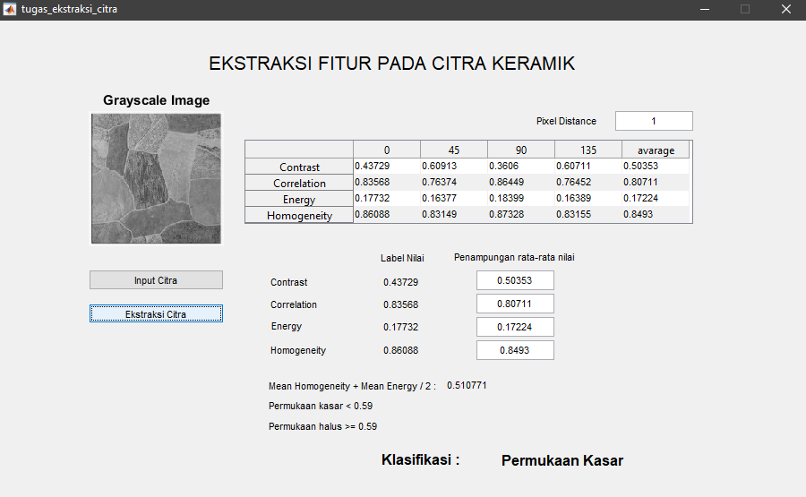

Github Repository Link :

https://github.com/Maoelan/1918008_Maulana-Muhammad_Comvis_Feature-Extraction